FYP - Automated Data Collecting System for Environment Using UAVs and Smartphones

User Guide

## How to run the system

1. Boot the Raspberry Pi

2. Connect the Wi-Fi form your raspberry Pi AP

3. run monitor.py on your laptop

python3 monitor.py

4. Press Connection in the navigation bar from the monitor APP

## How to save date

1. Press the Mission button on the Navigation bar

2. Press the Save As button to select the path that you want to save

## How to disconnect the UAV

1. Press the Connection button on the Navigation bar

2. Press the Disconnect button to disconnect the UAV

## How to clear the old mission

1. Press the Mission button on the Navigation bar

2. Press the New Mission button to start a new missions

It will clear all the data from previous mission, please save before you start a new mission.

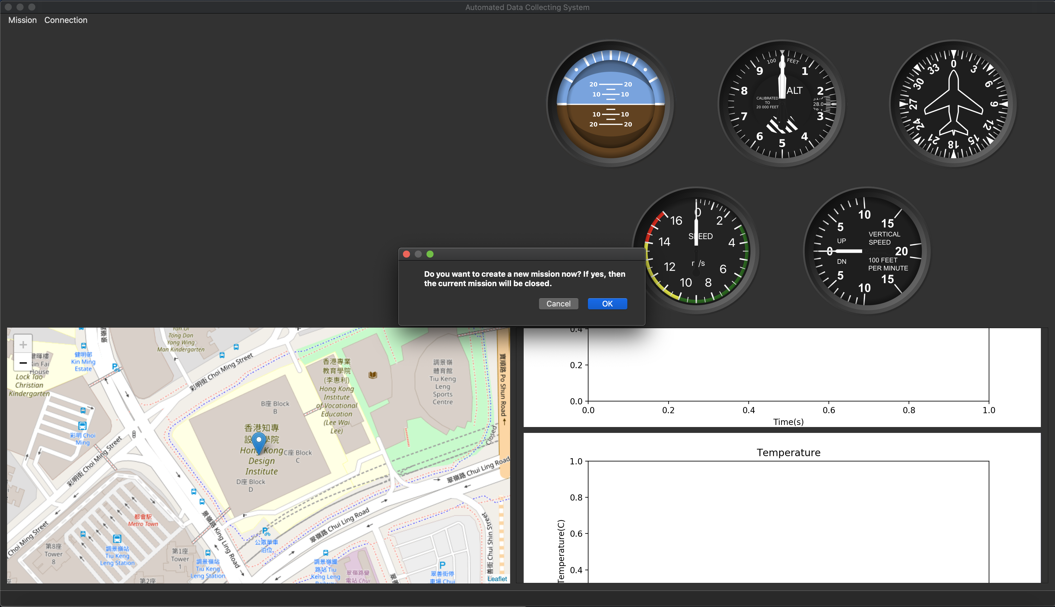

## How to quit the application

1. Press the Mission button on the Navigation bar

2. Press the quit button

## 